**DE TRE BASALE KOORDINATIONER**

FLEXION/EXTENSION

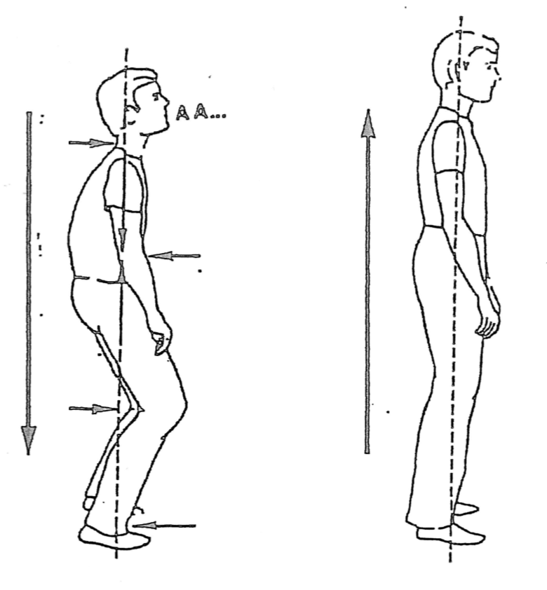

Kilde:

Jaques Dropsy 1984:”Den harmoniske krop”

ROTATION

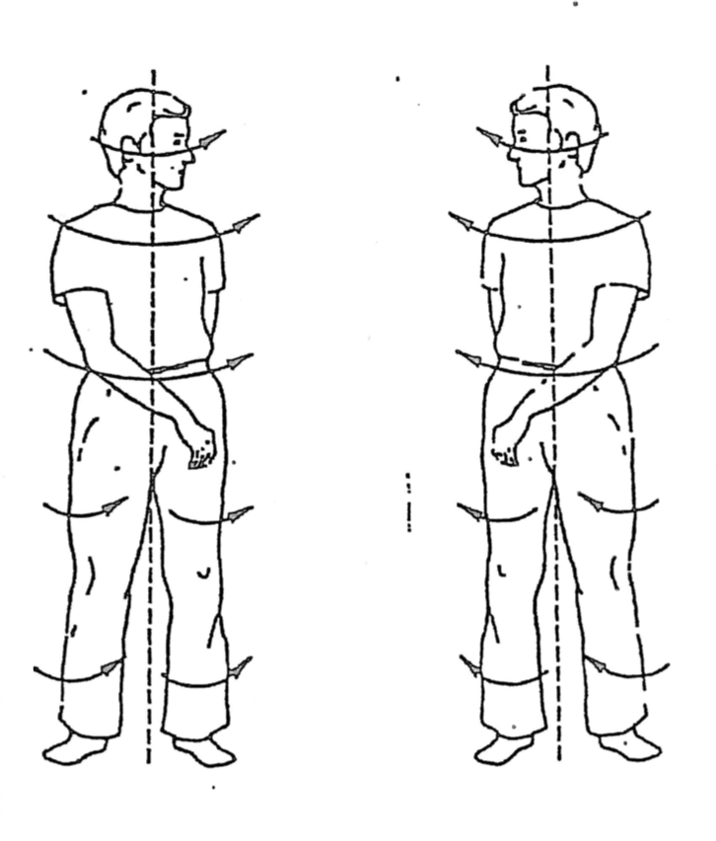

VRID/MODVRID

